# C3- S8 PRACTICE

# Flowchart to Boolean expression

Example

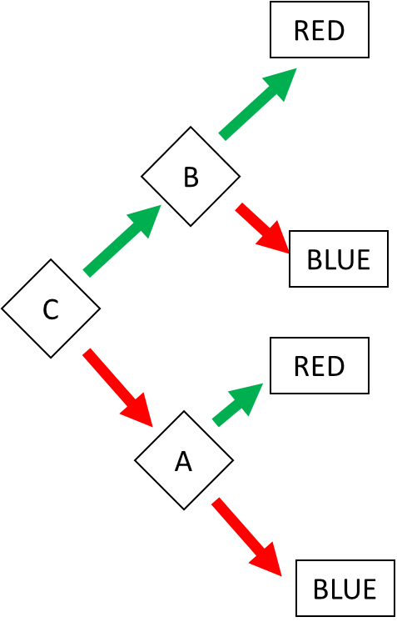

Answer:

RED = (C and B) or (!C and A)

BLUE = (C and !B) or (!C and !A)

# Ex 1: Find the Boolean expression of BLUE

BLUE=(a!b) or (ab!c) or (!a!d!b) = fales

RED =( abc) or (!ad) or (!a!db) = true

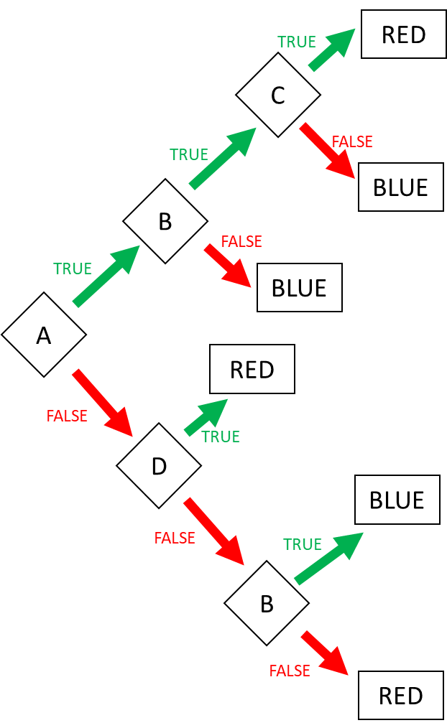

# Ex 2: Find the Boolean expression of BLUE

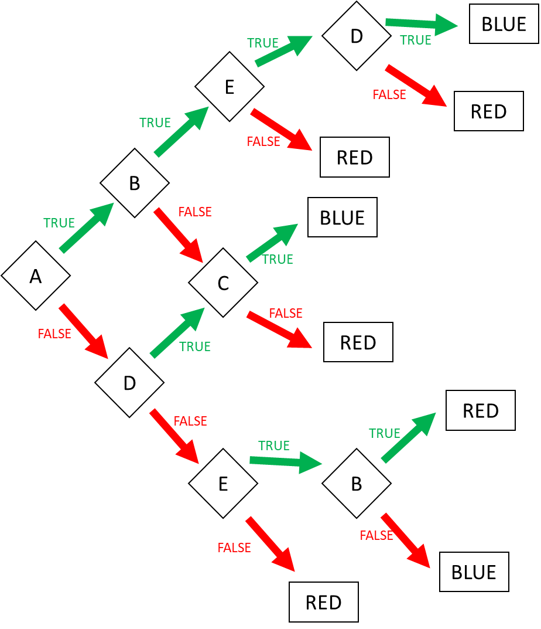

BLUE = (abed) or (!dc) or (a!bc) or (!a!deb) = true

RED= (a!b!c) or (ab!e) or (abe!d) or (!ad!c) or (!a!de!b) or (!a!d!e) = fales

Ex 2: Create the flowchart according to the expressions (4 flowcharts):

1. Go to the market = AB or !A!C
2. Go to swim = ( Sunny AND Sunday) OR ( !(Sunny) and Monday and no homework)
3. I’m superman = A!BCD or AB!CD or !ABCD
4. Happy = ABC!DE!F or A!BCD!EF or !ABCD!E or !A!BC

# 1D range colors

Example:

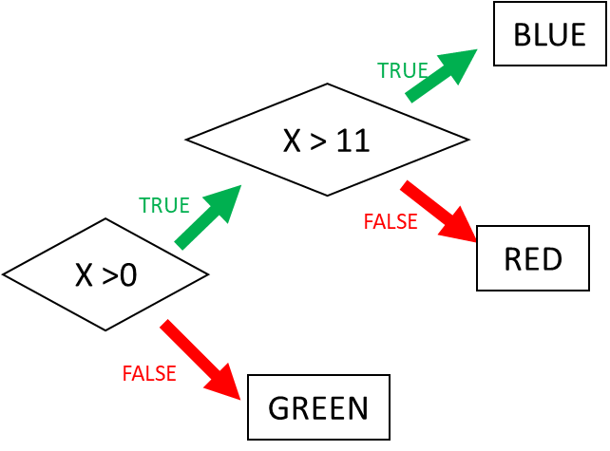

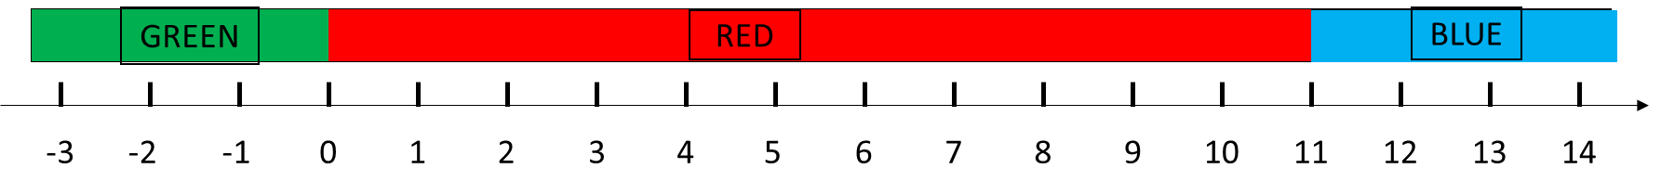

Ex 3: Ranges (1)

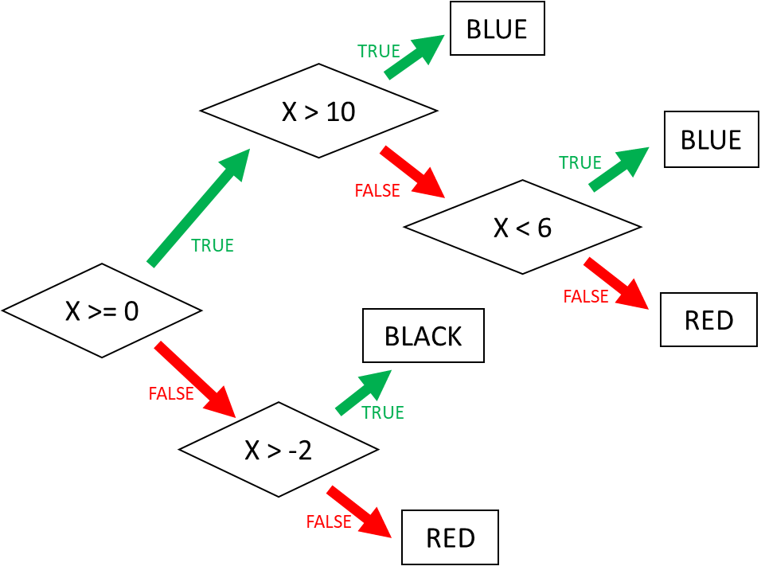

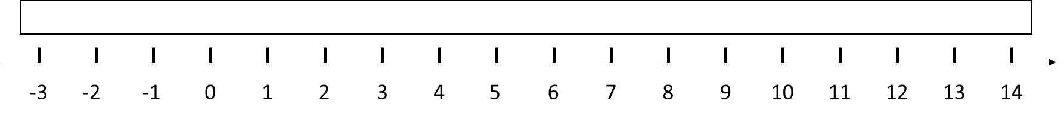

Ex 4: Ranges (2)

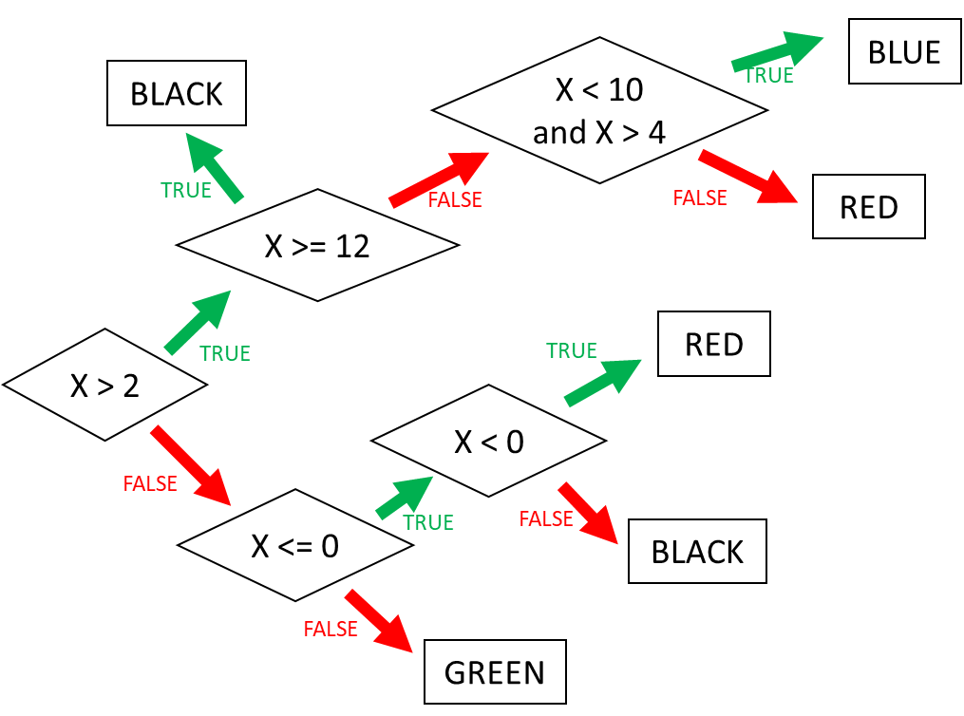



# 2D range colors

Example:

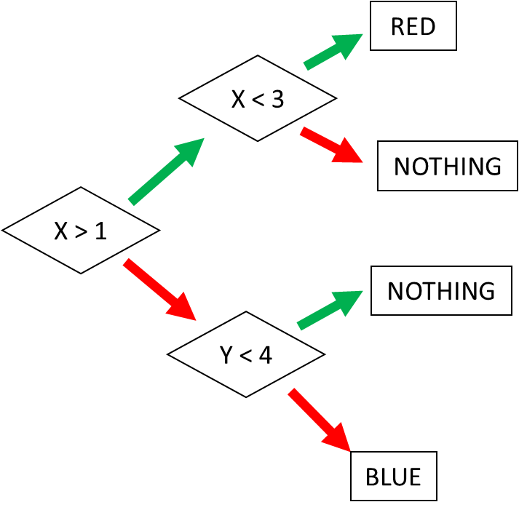 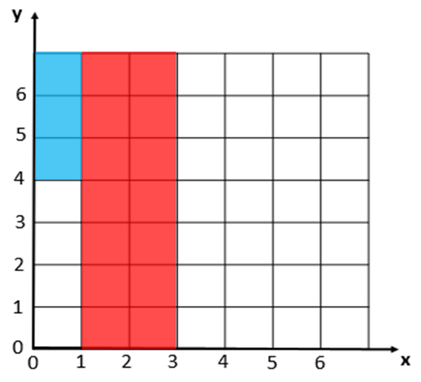

Ex 5: Square (1)

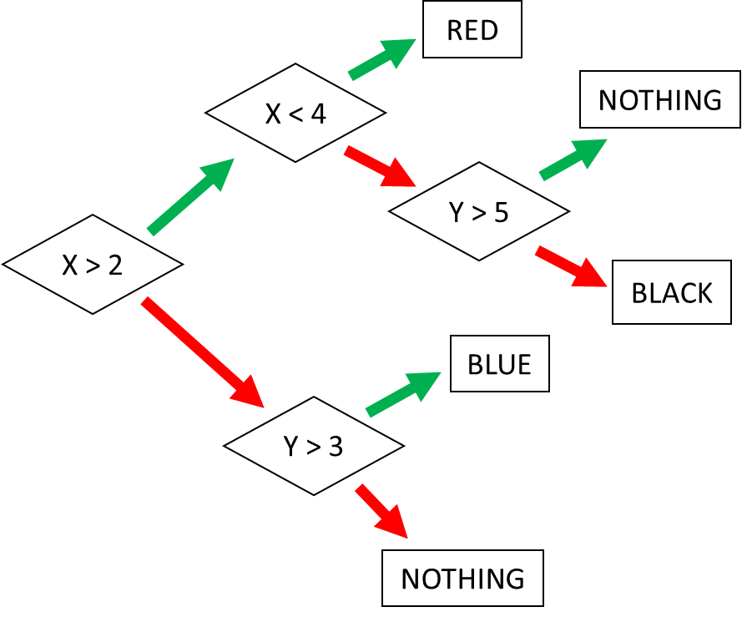 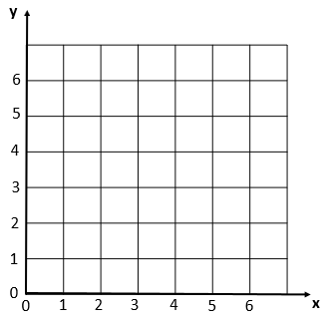

Ex 6: Square (2)

